Miriam Hagan
New Fellow: CISC HBCU Graduate Fellowship Pilot (CHFP)
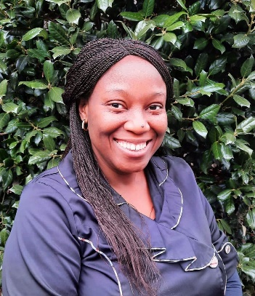 | Miriam is a PhD student in Nutritional Sciences at Howard University. She holds a bachelor’s degree in Food Science and Technology and a master’s degree in Project Management. She is also a PMP Professional. Miriam has over 10 years work experience in diverse roles in the food, health, transportation, education, and Biotechnology industry. Before this summer, she conducted systematic reviews for two scientific papers she authored on the effect of calcium fortified dairy products on bone health in the elderly population, and of protein supplementation in alleviating functional losses. Miriam was selected as AIM-AHEAD travel awardee for the CHITA conference, focused on applying AI in healthcare to enhance equity and diversity. During this summer, Miriam worked as a Grad Intern at Amgen to develop a unique tool to automatically calculate total extractables.  Miriam wishes to advance her career in the Nutrition, Food, and Health industry. Her current research interest is on the effect of seaweeds on the microbiome.  Miriam is enthused to be part of the fellows at the CISC HBCU Graduate Fellowship Pilot (CHFP).

