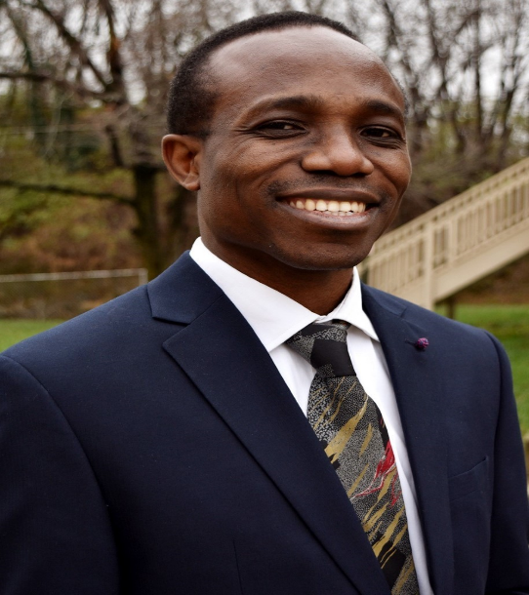
Christopher Iweriebor is a graduate student at the College of Agriculture, Urban Sustainability and Environmental Sciences of the University of the District of Columbia. He is pursuing a major in Urban Agriculture and has worked on a seedling project under Dr. William Hare to grow seedlings for DC ward 7 community in Spring and Summer 2022.
Christopher graduated with a cum laude distinction in accounting degree from the University of the District of Columbia School of Business and Public Administration. He is a member of the National Association of Black Accountants (NABA) UDC College chapter. He volunteered at the UDC NABA tax clinic in spring 2018 and 2019. He interned at DC Water Department of Finance, Accounting and Budget in Summer 2019. Christopher received SBPA scholarship award in Fall 2019 and was selected to represent the University of the District of Columbia at the Thurgood Marshall College Fund’s 2019 Leadership Institute.

